Gloucestershire Schools
English Schools’ National Championships 2026

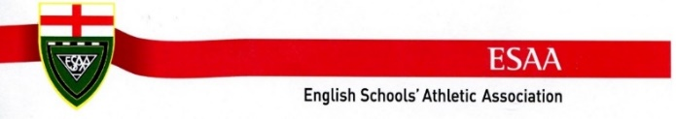

Age | Event | Name | Result
SG | PV | Arisa Burgess | 4th 3.55m
IB | u18 110mH | Caleb Green | Bronze 14.00s PB
SB | Javelin | Charlie Mason | Gold 63.73m
SB | 200m | Dan Jackson Osborne | 14th 22.25s PB
SG | 1500m | Ella Spencer | 10th 4:47.36min
IB | 200m | Enrico Savioli | 16th 22.84s
IB | Dis | George Iddon | 7th 42.34m
SB | Jav | Henry Watson | 5th 58.02m SB
SG | HJ | Isla Pain | 4th 1.69m
JB | TJ | Jake Betterton | 8th 12.18m PB
SB | 100m | James Arminio | Gold 10.45s
JB | LJ | Jay Li | 12th 5.63m
JG | 1500m | Joselyn Hathway | 10th 4:41.11min
SB | Shot | Lewis Burnett-Hockey | 9th 12.81m PB
JG | LJ | Lily Herdman | 9th 5.21m
IG | 3000m | Lily-Sienna Leon-Hodgson | 23rd 10:50.54min
IB | Ham | Lucas Clark-Savage | 11th 44.91m
IG | Jav | Lucy Bull | Gold 52.25m CBP
SG | 200m | Melody Benn | 10th 24.91s
SG | 800m | Millie Cossins | 5th 2:13.08min
SB | u19 110mH | Oliver Belbeck | 6th 16.41s
IB | 200m | Oscar Beattie | 22nd 23.00s
IB | u16 300mH | Oscar Elksnis | 23rd 45.59s (fell at the last hurdle but finished)
SB | TJ | Oshotare Kadiri | 8th 14.17m
IG | 800m | Rosie Atkins | 11th 2:12.19min PB
JG | 100m | Rubi Iheme-Madukairo | 29th 12.92s PB
SG | 3000m | Ruth Brook | 4th 10:03.52min
IB | u18 110mH | Sam Jeenes | 31st 22.90s (fell at first hurdle but finished)
IB | Jav | Theo Nock | 5th 53.44m PB
SB | Shot | William Richards-Baldwin | 4th 15.27m
JB | Ham | Zachary Brink | 6th 45.86m PB

8 Personal Bests (PB), 1 SB (Season’s Best),
1 Bronze, 3 Gold, 1 Championship Best Performance (CBP)

